Assessment Task 3 – Written Report

Table of Contents

## Test Plan

## Test Log

## Bug Tracker

## Test Data

## Known Issues

## User Feedback

Ctrl + Left click to follow hyperlinks

# Test Plan – Back to Top

|  |  |  |  |
| --- | --- | --- | --- |
| Date | Version | Description | Result |
| 8th-Sept | v0.4 | Check all GUI controls | Fail – See Test Log |
| 8th-Sept | v0.5 | Re-check all GUI controls | Ok |
| 8th-Sept | v0.5 | Check GUI Input validation | Fail – See Test Log |
| 8th-Sept | v0.5 | Re-check GUI Input validation | Fail – Known issue |
| 9th-Sept | v0.6 | Check SQL connection | Fail – See Test Log |
| 9th-Sept | v0.7 | Re-check SQL connection | Ok |
| 9th-Sept | v0.6 | Check SQL Insert | Ok |
| 10th-Sept | v0.8 | Check multiple entries | Fail – See Test Log |
| 10th-Sept | v0.8 | Re-check multiple entries | Ok |

# Test Log – Back to Top

|  |  |  |  |  |  |  |
| --- | --- | --- | --- | --- | --- | --- |
| Date | Version | Description | Result | Reproduction Steps | Action | Status |
| 8th-Sept | v0.4 | Check all GUI controls | Fail – See Bug #00001 | Select any combobox Type in a value Click Save Program saves entered value to database even though it is not a valid option. | Set Combobox DropDownStyle to ‘DropDownList’ prevents the user from manually entering a value. | Ok |
| 8th-Sept | v0.4 | Check all GUI controls | Fail – See Bug #00002 | Enter 32767 characters into any textbox. As the SQL database will not accept this number of characters the program throws an error. | Set MaxLength property to 30 to prevent this unintended issue. | Ok |
| 8th-Sept | v0.5 | Check GUI Input validation | Fail – See Bug #00003 | Enter a non-numeric value into the amount textbox | See Known Issues | To do! |
| 9th-Sept | v0.6 | Check SQL connection | Fail – See Bug #00004 | Attempt to save any valid inputs | Program does not correctly connect to the Database. Corrected parameterised inputs. | Ok |
| 10th-Sept | v0.8 | Check multiple entries | Fail – See Bug #00005 | Choose a transaction type and enter appropriate values to all fields. Save the transaction. Choose a new transaction type and re-enter appropriate values to all fields. | Moved open connection code to before saving parameterised inputs. | Ok |

# Bug Tracker – Back to Top Bug #00001

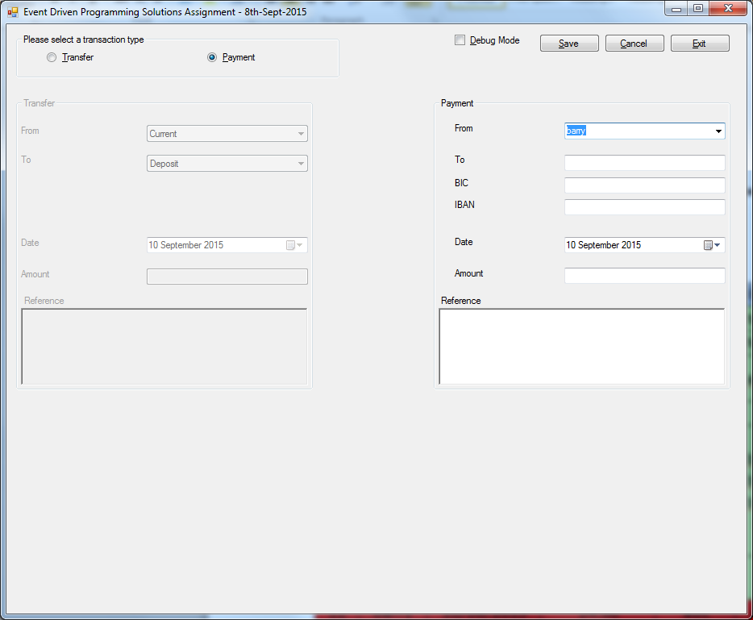

See Test Data ID#22

#### Bug #00002

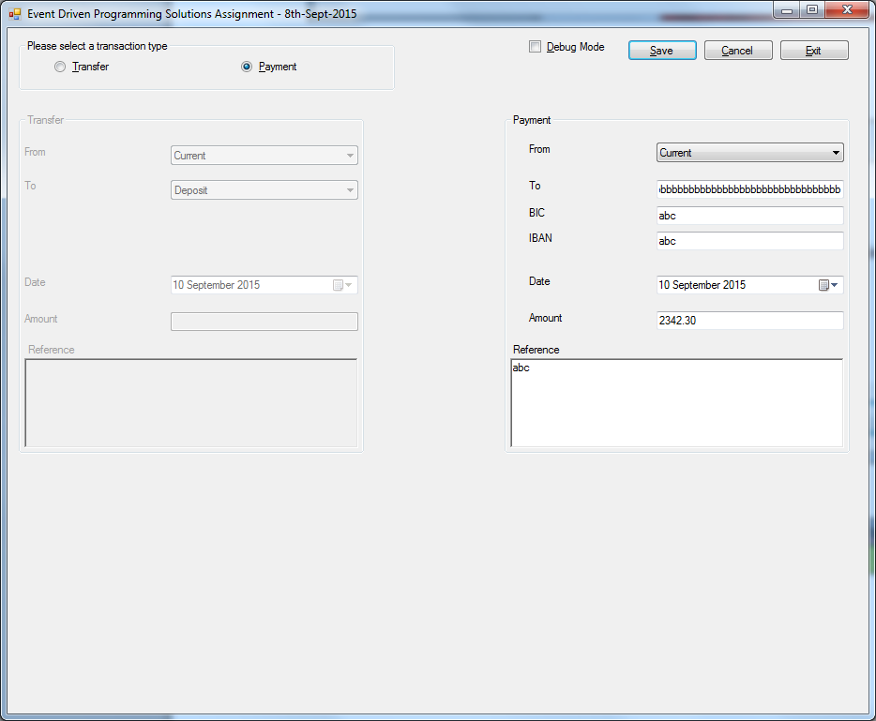

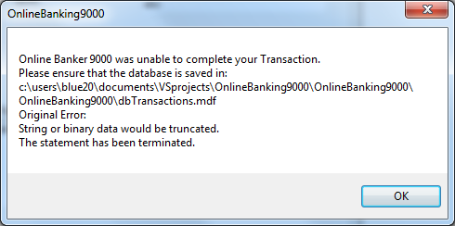

#### Bug #00003

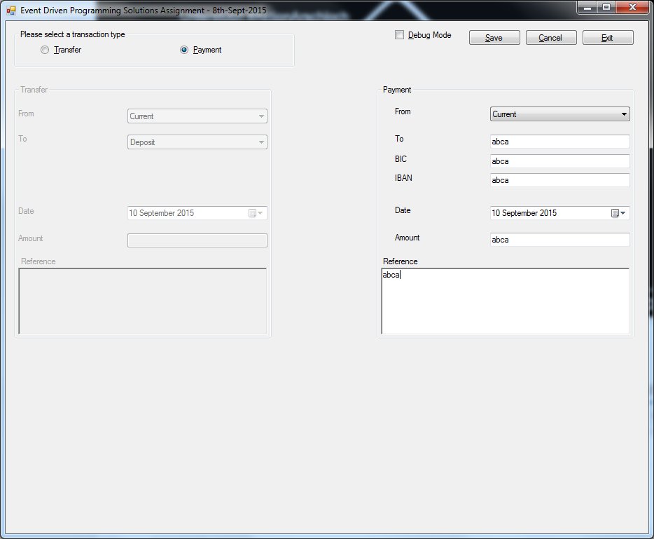

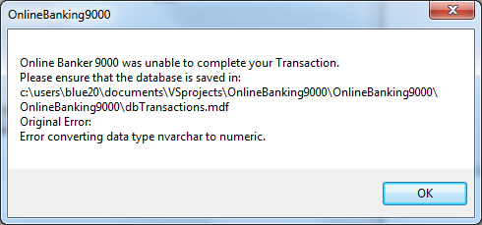

Program halts and will not enter any data to the database.

#### Bug #00004

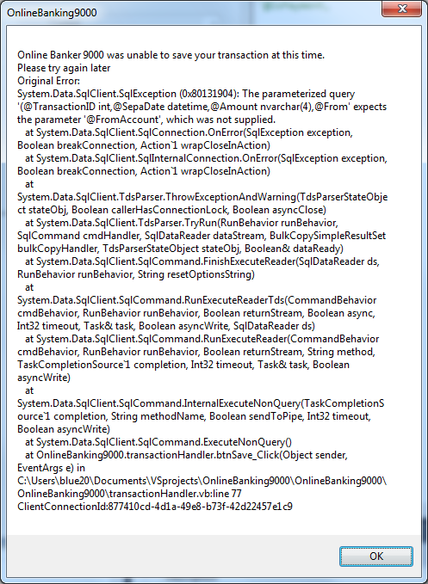

#### Bug #00005

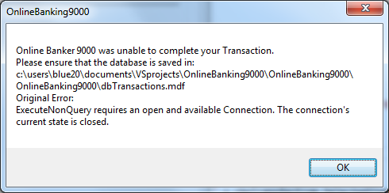

# Test data – Back to Top

|  |  |  |  |  |  |  |  |  |  |
| --- | --- | --- | --- | --- | --- | --- | --- | --- | --- |
| ID | Payee | Date | Amount | BIC | IBAN | IsPayment | From | To | Reference |
| 1 | test1 | 09/09/2015 | 420.00 | test2 | test3 | True | Current |  | test4 |
| 3 | Not a | 09/09/2015 | 1999.00 | Not a | Not a | True | Current |  | Not a test |
| 4 | abcd | 25/09/2015 | 4123.00 | abcd | abcd | True | Current |  | abcd |
| 5 |  | 27/09/2015 | 1200.00 |  |  | False | Deposit | Loan | Test |
| 19 | Can't think of more names9999! | 27/11/2015 | 444.00 | aaaaaaaa | bbbbbbbbbbbbbb | True | Current |  |  |
| 20 |  | 13/09/2015 | 4443.23 |  |  | False | Loan | Current | Ciaran woz ere! |
| 22 | barry | 10/09/2015 | 24.00 | abc | abc | True | barry |  | 1234adf |

# Known Issues – Back to Top

No input validation on Amount textbox, upgrading to ‘NumericUpDown’ box in next version, as this control only allows numeric inputs.

Debug mode should be removed before pushing to live platform.

# User Feedback – Back to Top

User 1: Debug mode is unsecure it allows the user to directly access the transaction database.

Answer: Debug mode will not be available in release version and is only provided for internal testing.

User 1: No default setting selected on program launch and on cancel/save event.

Answer: The OnlineBanking9000 designer felt that a default setting was superfluous in a program with a binary decision tree. This may be reviewed at a later date when stats have been compiled on the most selected transaction type. ‘Set default transaction’ feature will be added in a future version of the OnlineBanking9000

User 2: Combobox is editable, allowing the user to enter any value.

Answer: This Bug is addressed in v0.5 or later.

User 2: No label provided for each transaction group-box, instructions are unclear!

Answer: Feature added in v0.6 or later.